EBS 26 Aug Extend the size of rootEBS

Sohel Pathan

**Task 1**

**\*\*Create One instance having attached root and ebs volume\*\***

Create One instance having attached root and ebs volume

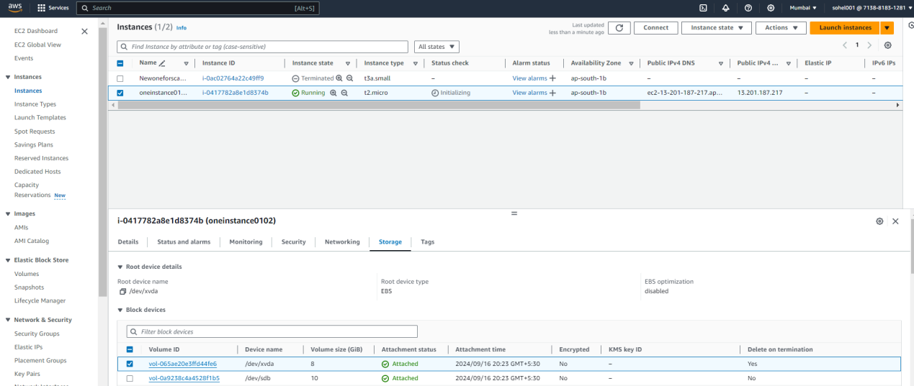

Attaching EBS to instance

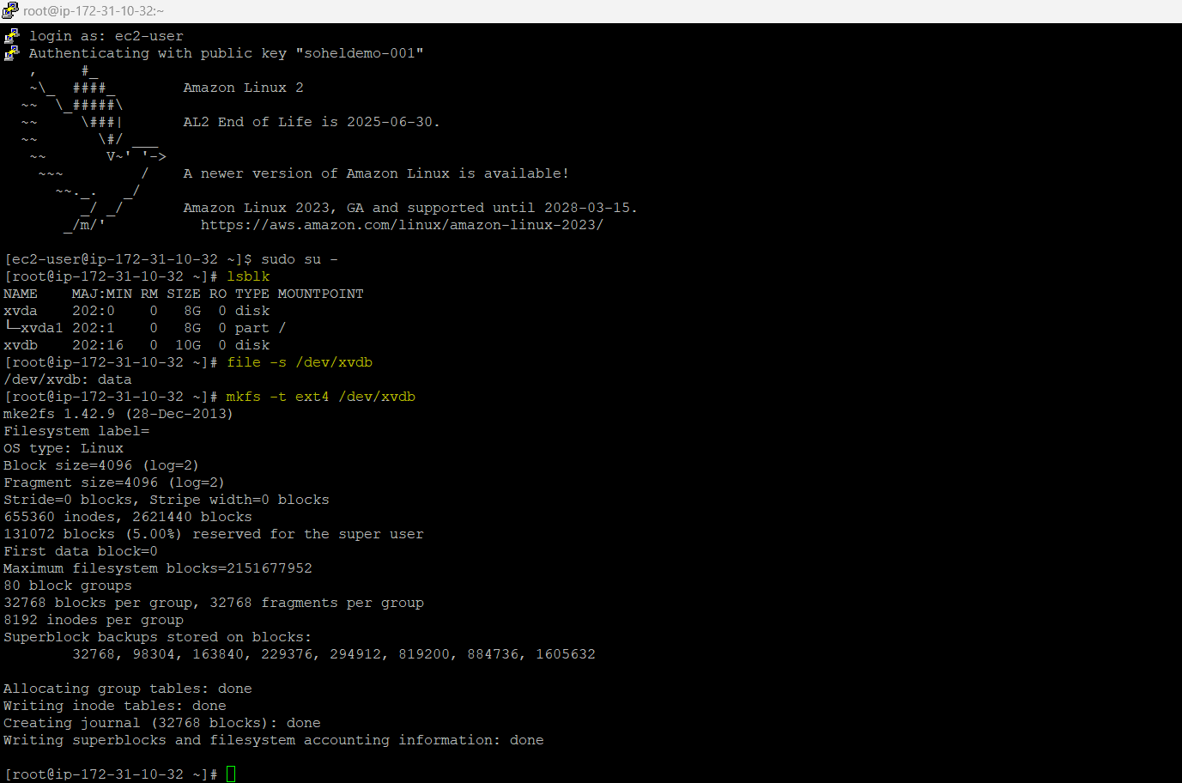

We can see both volumes are attached.



**\*\*Increase the size of root EBS volume\*\***

1. If we need to increase the size of root ebs volume snapsot is required.(Snapshot is chargable.

Size of snapshot = size of volume)

Create snapshot of root ebs volume

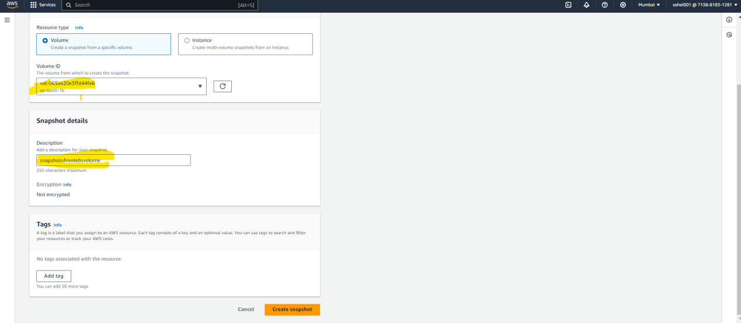

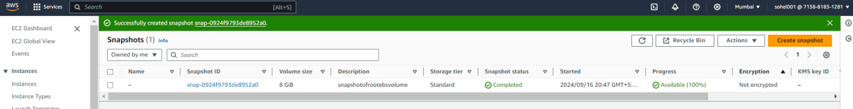

1. Create volume using snapshot **make Availability of zone and instance is same.**

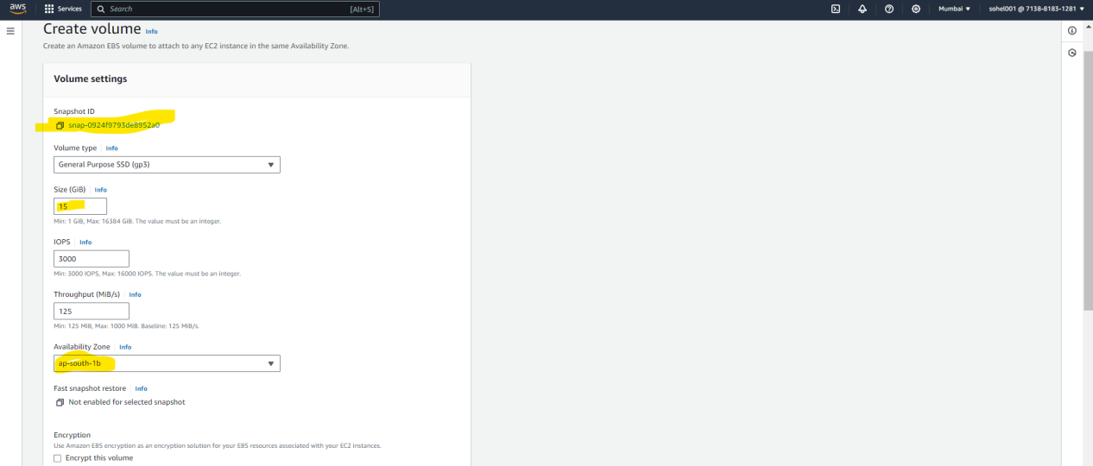

1. Stop instance

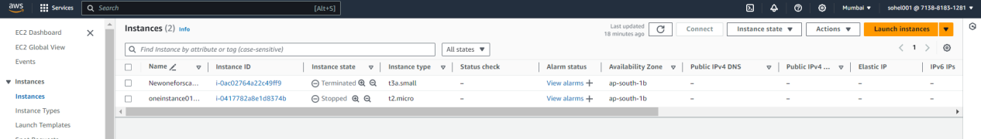

1. Detaching root ebs volume

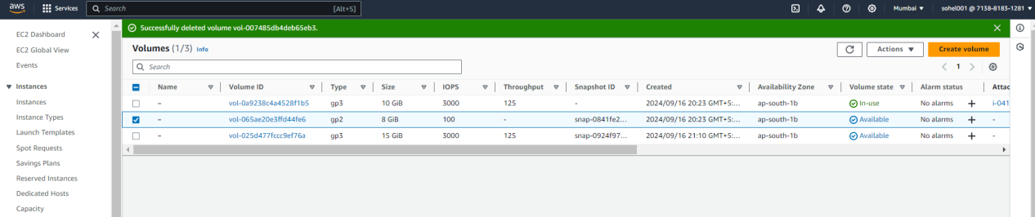

1. Attaching root ebs volume from Snapshot to the instance

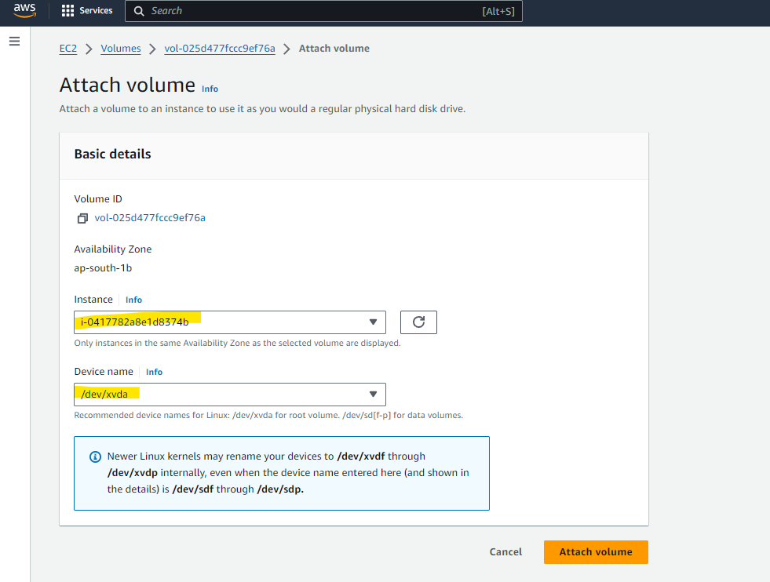

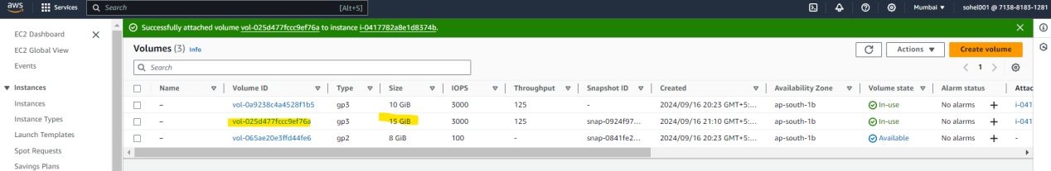

1. Start the instsance we se the volume is extended

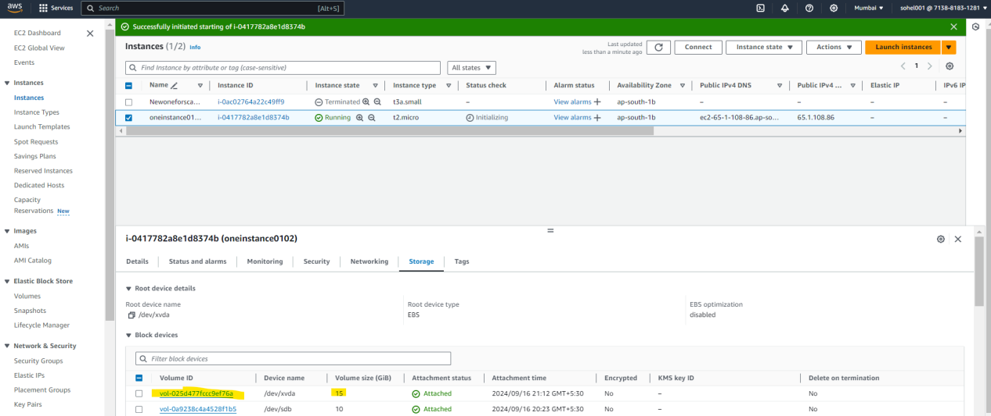

Succesfully extended root ebs volume to 15 gb

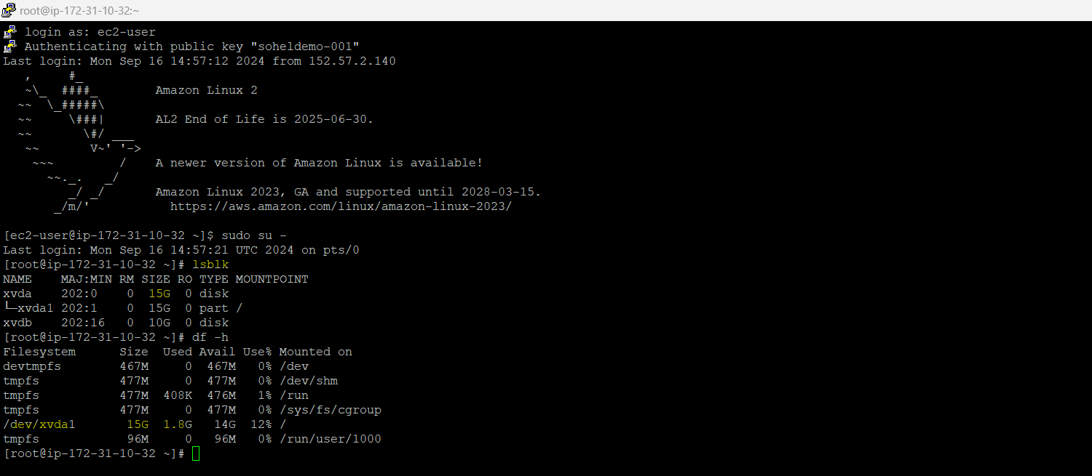

1. **Increase the size of EBS Volume**

Create one instance having Root EBS volume and EBS volume of 8gb & 5 gbeach

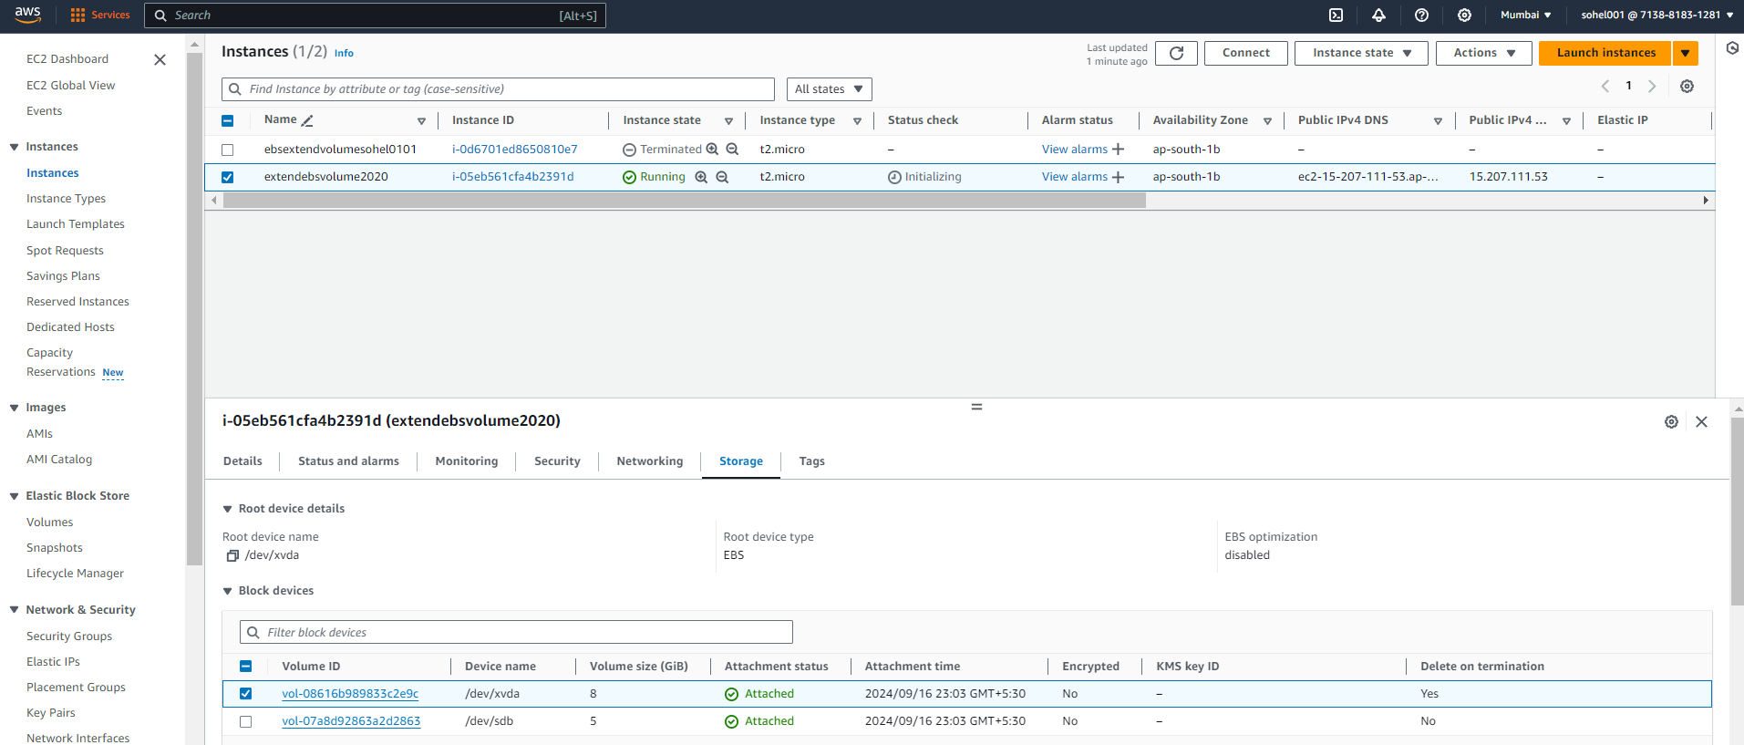

Need to increase size of EBS volume

Before increasing the size:

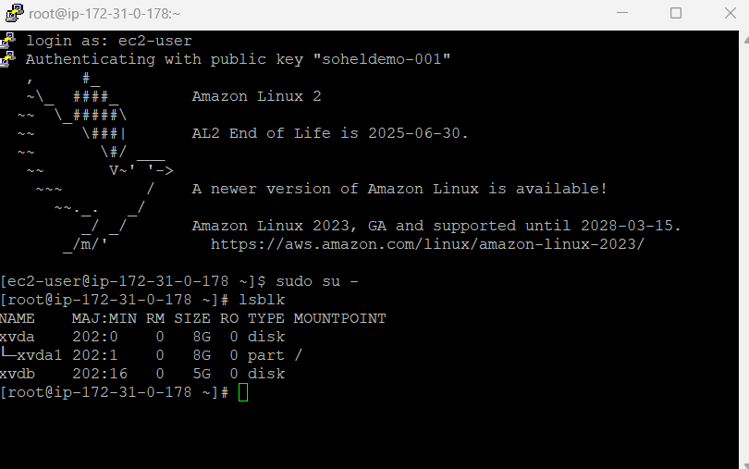

Modify the size of as per we want:

Succesfully extended the size of EBS Volume

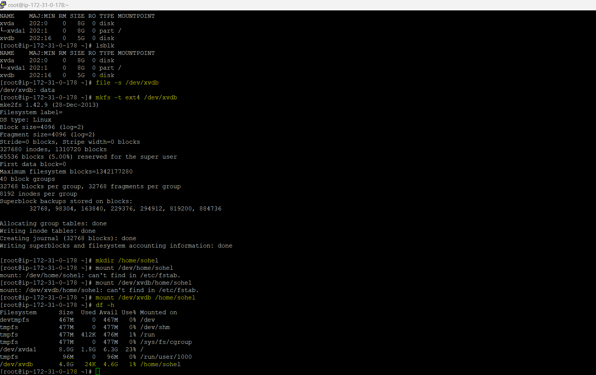

Now use Resize2fs command to extend the volume

